**REPORT FOR CSP**

As a project work for Course

**ARTIFICIAL INTELLIGENCE (INT 404)**

__________________________________________________________________________

NAME : Mansi Dhall

REGISTRATION NO. : 11815802

PROGRAM : CSE (B.Tech)

SEMESTER : 4

SCHOOL : School of Computer Science

and Engineering

NAME OF UNIVERSITY : Lovely Professional University,

Phagwara, Punjab, India

DATE OF SUBMISSION : 25MAR-31MAR

***Abstract: -***

There are various problems concerning artificial intelligence which can be stated in the form of constraint satisfaction problems (CSP). These problems are defined by a set of variables and a set of constraints in the range of selectable values for variables. Solution of this problem is a set of values for variables so that all constraints of the problem are satisfied. A part of algorithms for CSP are forward algorithms. They are used to check consistency and constraint propagation. In this project I have used an algorithm that can provide different values to different variables for any word equation problem. User can input any equation and get the results with mappings and user will get all the possible solutions for that particular problem he will input.

***Acknowledgement: -***

I have taken efforts in this project. However, it would not have been possible without the kind support and help of many individuals and organizations. I would like to extend my sincere thanks to all of them.

I am highly indebted to Sagar Pandey Sir for their guidance and constant supervision as well as for providing necessary information regarding the project & also for their support in completing the project.

I would like to express our gratitude towards my parents & members of Lovely Professional University for their kind co-operation and encouragement which helped me in completion of this project.

**Table of Content**

|  |  |  |
| --- | --- | --- |
| **Sr. No.** | **Topic** | **Page** |
| 1. | Abstract | 2 |
| 2. | Acknowledgment | 3 |
| 3. | Introduction | 5 |
| 4. | Library Used | 6 |
| 5. | Process of solving CSP | 7 |
| 6. | Application | 8 |
| 7. | Conclusion | 8 |
| 8. | References | 9 |

***Introduction: -***

In artificial intelligence and operations research, **constraint satisfaction** is the process of finding a solution to a set of constraints that impose conditions that the variables must satisfy. A solution is therefore a set of values for the variables that satisfies all constraints—that is, a point in the feasible region.

The techniques used in constraint satisfaction depend on the kind of constraints being considered. Often used are constraints on a finite domain to the point that constraint satisfaction problems are typically identified with problems based on constraints on a finite domain. Such problems are usually solved via search, in particular a form of backtracking or local search.

Constraint satisfaction originated in the field of AI in the 1970s. During the 1980s and 1990s, embedding of constraints into a programming language were developed. Languages often used for constraint programming are Prolog and C++.

***Library Used: -***

* Python Itertools: Python’s Itertool is a module that provides various functions that work on iterators to produce complex iterators. This module works as a fast, memory-efficient tool that is used either by themselves or in combination to form **iterator algebra**.

***Process of solving CSP: -***

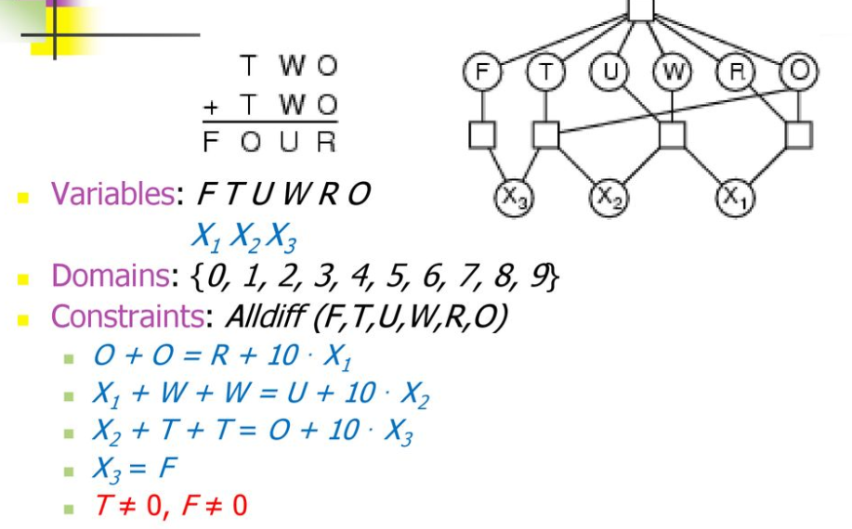

**Cryptarithmetic problem**

***Applications: -***

Constraint Satisfaction can be used in solving many problems,

Example: 8 queen problem, map coloring, finding the relations of family tree, verbal cryptarithm, alphametic, skeletal, digimetic problems etc.

***Conclusion: -***

This project work of Constraint Satisfaction started with a brief introduction of the technology. The project part of the Report was based on software development for solving cryptaritmetic problem. At the later stage we discussed different tools for bringing that idea into practical work. After the development of the software finally it was tested and results were discussed, few deficiencies factors were brought in front. After the testing work, advantages of the software were described and suggestions for further enhancement and improvement were discussed.

***References: -***

1. Stackoverflow at youtube.com
2. wikipedia.org/wiki/Constraint_satisfaction
3. <https://www.geeksforgeeks.org/python-itertools/>